OKC Innovation Hall – Building and Parking Instructions
OKC Innovation Hall is located at 316 NE 9th St, Oklahoma City, OK 73104.
For those traveling on I-35 Northbound towards downtown OKC:
- At the I-35, I-40, I-235 interchange, continue straight onto I-235 Northbound and then take Exit 1E. Continue straight on the exit ramp and turn right on NE 10th St. Turn right on N. Stiles Ave. and turn right on NE 9th St.
For those traveling on I-35 Southbound and I-40 Westbound towards downtown OKC:
- At the I-35, I-40, I-235 interchange, take Exit 126 onto I-235 Northbound. Continue on I-235 Northbound for approximately one mile and then take Exit 1E. Continue straight on the exit ramp and then turn right onto NE 10th St. Turn right on N. Stiles Ave. and turn right on NE 9th St.
For those traveling on I-40 Eastbound towards downtown OKC:
- At the I-35, I-40, I-235 interchange, take Exit 151C onto I-235 Northbound. Continue on I-235 Northbound for approximately one mile and then take Exit 1E. Continue straight on the exit ramp and then turn right onto NE 10th St. Turn right on N. Stiles Ave. and turn right on NE 9th St.
For those traveling on I-235 southbound towards downtown OKC:
- Take Exit 1G. Turn left on NE 10th St, cross over I-235, turn right on N. Stiles Ave., and turn right on NE 9th St.

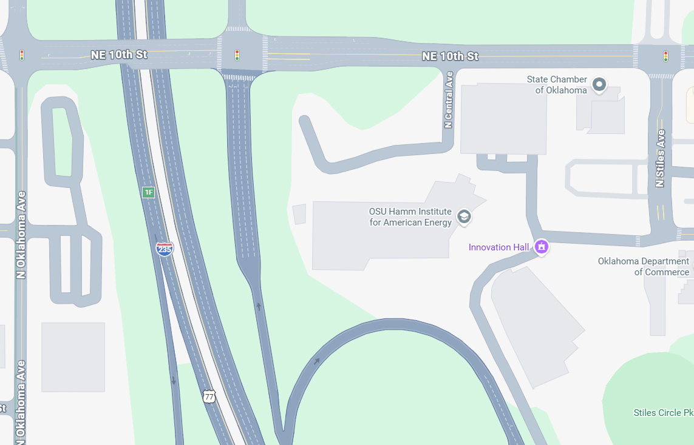

Innovation Hall is a two-story building with metallic paneling and a rounded north-facing façade:

Parking is located in the garage just east of Innovation Hall next to the red brick Oklahoma Department of Commerce building. There is a gate for the parking garage, and you may need to take a ticket for the gate to raise. However, you should not be charged for parking.

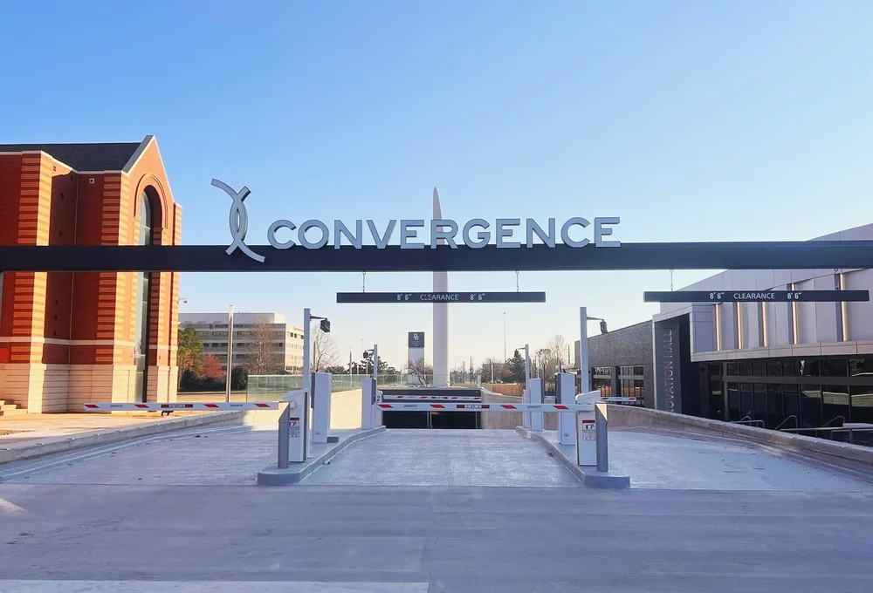

Once in the garage, drive towards the yellow building entrance and take the elevator to the first floor.

